Assignment No : 1 Terraform
Build an AWS VPC infrastructure using Terraform that includes public and private subnets, Internet Gateway-based routing, and an EC2 instance accessible over HTTP. The configuration should allow User Data to be customized and should expose the EC2 instance’s public IP address as a Terraform output.
1.Aws provider configuration
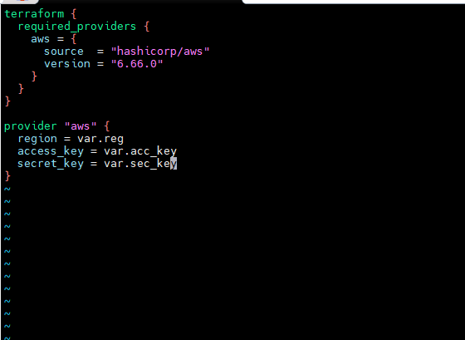

2. Input variables and user data
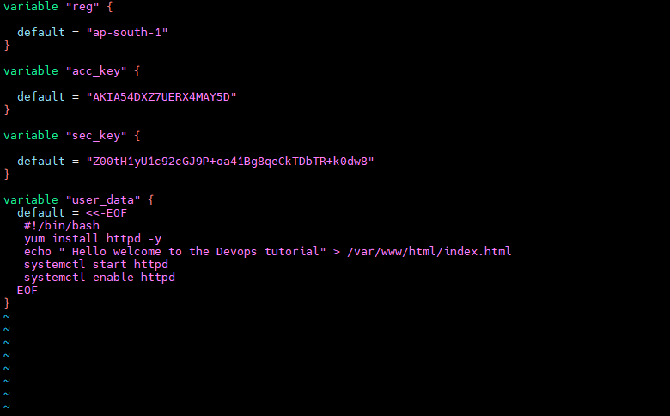
3. vpc , subnet, internet gateway, public routing, security group and Ec2 instance configuration.

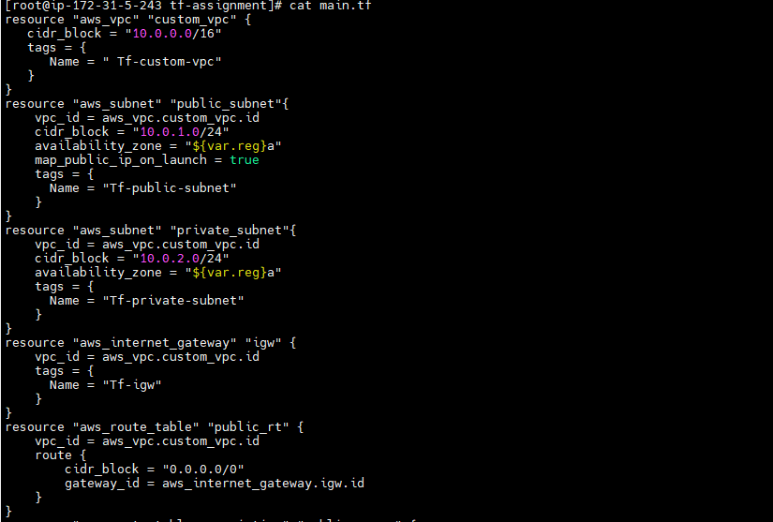
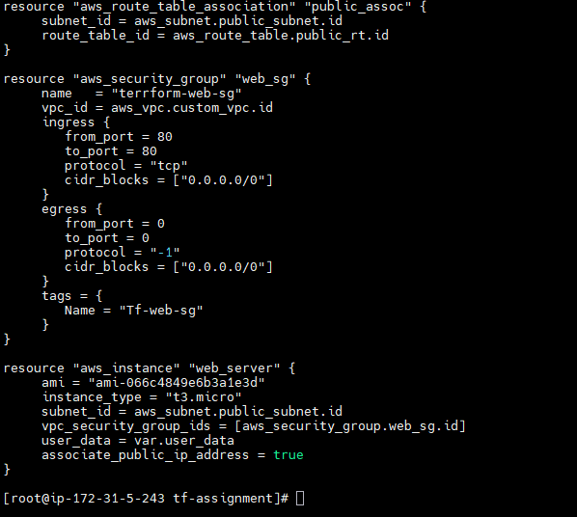

4. Terraform output
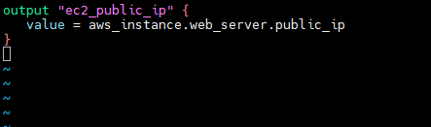

5.Terraform Deployment
Terraform successfully deploys the infrastructure and outputs the EC2 instance’s public IP address.

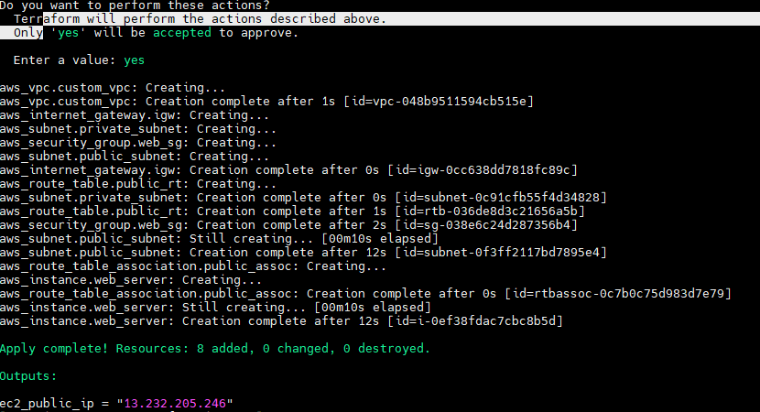

6.The EC2 instance’s public IP address is accessed through a web browser


